
HOW TO REPORT VOLUNTEER ACTIVITY
Sheldon and Black Rock Collection Project

- Follow this link if you haven’t signed up yet and sign in to your account where prompted.
- Hit the response button:
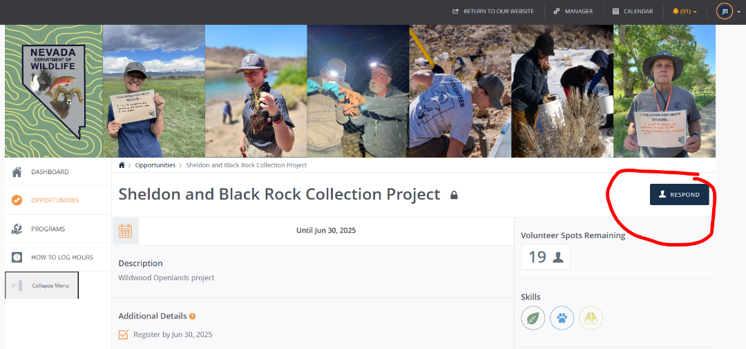
- You don’t need to add a response, but if you want you can add a short note and then hit Submit.
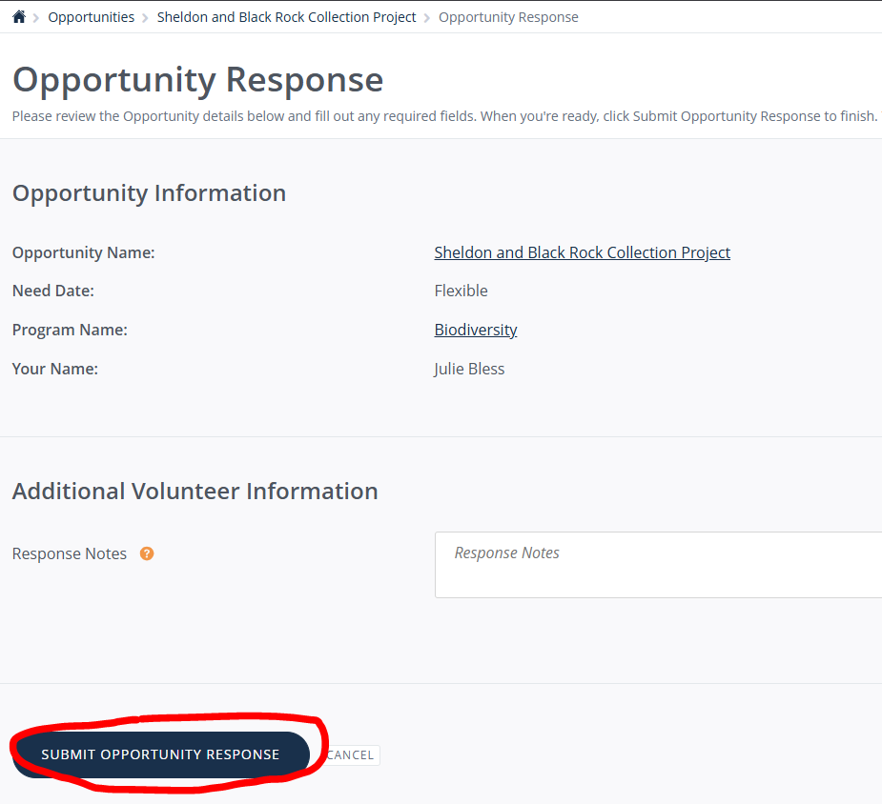

- From your Dashboard, select “Add Hours” on the top right of the page.

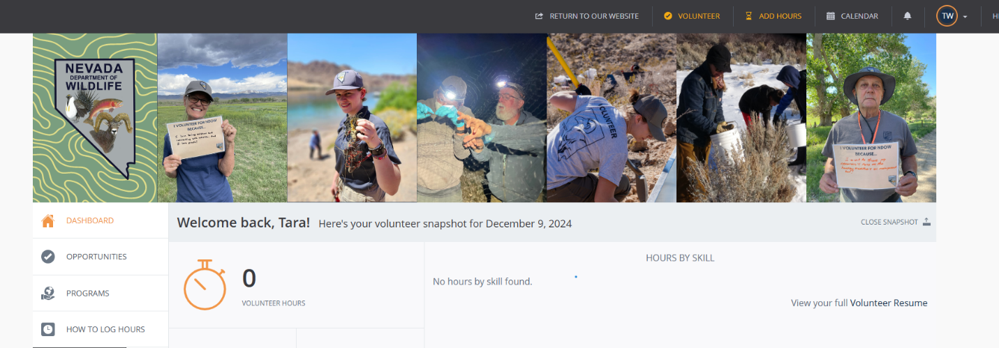

- Select the “Sheldon and Black Rock Collection Project” opportunity from the drop-down menu. If you do not see the project as an option, make sure you’ve done steps 1-3 first. Answer the Hours Questions to correctly calculate your activity.
  - For Hours Question #1 (what time did you leave): This is the time you left your house or camp. Enter on the half or whole hour. For this example, we left our house at 6:00 am.
  - For Hours Question #2 (what time did you return): This is the time you returned to your house or camp. Again, enter on the half or whole hour. For this example, we returned to our house at 12:00 pm.
  - For Hours Question #3 (round trip travel hours): This is accounting for your roundtrip travel time. For this example, our travel was about an hour each way so our roundtrip is 2 hours.
  - For Hours Question #4 (break): For every 6 hours of time recorded, including travel, a .5 hour needs to be subtracted from your total time. Even if you did not actually take a break this must be considered, or your time sheet will be rejected. For this example, we worked 6 hours so we need to take a .5 hour break. If we worked 12 or more hours we would take off 1 hour and so on. We need to double check that our total hours is 5.5 in the “Hour Details”

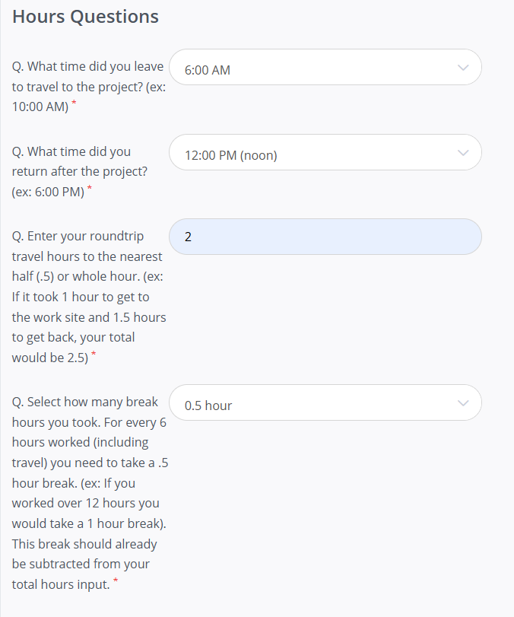
*Your start time to end time, minus any breaks, must equal your ‘Hours Worked’ or your timesheet will be rejected. This is the most common mistake. Double check your math and don’t forget to subtract a break if your start time and end time equal 6 or more hours.*

- Fill out your Hours Details.
  - Select the correct date. Your Hours Worked should add up to the time declared in Hours Questions 1, 2, and 4. Start Time, End Time, and subtracting out a break if necessary. Example in previous figure has an 6:00 am start and a 12:00 pm return. 6am – 12pm is 6 total hours so a .5 hour break needs to be subtracted out making the correct submitted total hours 5.5 hours. *Your hours will automatically populate when you choose an opportunity from the drop down. Be sure to double check this and edit the hours box before submitting.
  - You can add a short description of what you did or where you were.
  - Enter exact Miles Traveled if you drove your own vehicle. If you were a passenger or drove a state vehicle you need to enter 0 miles. Entering miles is completely optional even if you did drive your own vehicle. If you enter miles you must add a screenshot of a map (Google map, OnX, or equivalent) that matches input miles exactly. Example included below: The attached map labeled ‘OPP 1’. For this example, the attached map shows 61.3 miles. Roundtrip that equals 122.6 which was input. *If the attached map does not equal the roundtrip mileage input, we have to reject your timesheet. If you input miles and do not attach a map we have to reject your timesheet.*
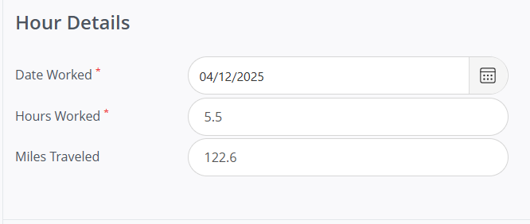
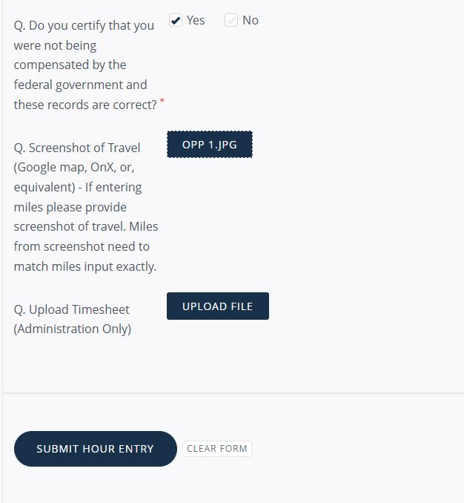

- Select ‘Yes’ to certify that you were not being compensated by the federal government and these records are correct. Double check everything looks right and hit submit. If you do not click yes, we have to reject your timesheet.

- Time needs to be entered to be approved within 2 weeks of time of service.

Questions? Contact your regional Volunteer Coordinator.
Eastern  Nicole Hamblin  Nicole.hamblin@ndow.org  (775) 777-2388 | Southern  Michelle Lopez  Michelle.lopez@ndow.org  (702) 668-3552 | Western/Statewide  Julie Bless  Jbless@ndow.org  (775) 688-1406

